**DAILY ONLINE ACTIVITIES SUMMARY**

|  |  |  |  |  |  |
| --- | --- | --- | --- | --- | --- |
| **Date:** | | **05/06/2020** | | | |
| **Name of the Faculty** | | **Shilpa** | | | |
| **No. of Students Allotted for monitoring** | | | | **19** | |
| **Progress** | | | | **Good** | |
| **Whether collected report from all the allotted students** | | | | **15 submitted.** | |
| **Online Test Summary** | | | | | |
| **Subject** |  | | | | |
| **Semester** |  | | | **Duration** |  |
| **No. of students Taken** | | |  | **Passing %** |  |
| **Certification Course Summary** | | | | | |
| **Course** | | 1. **Webinar on Brain Computer Interface** 2. **Webinar on Personal Finance for Faculty in Engineering Colleges** 3. **Skycampus Digital Knowledge** | | | |
| **Certificate Provider** | | 1. **NITK in association with Pantech** 2. **New Horizon College of Engineering** 3. **ICT Academy** | | **Duration** | **2 Hour each** |
| **Coding Challenges** | | | | | |
| **Problem Statement: -** | | | | | |
| **Status: -** | | | | | |
| **Uploaded the report in Github** | | | |  | |
| **If yes Repository name** | | | |  | |
| **Uploaded the report in slack** | | | |  | |

**Certification/webinar Course Summary**

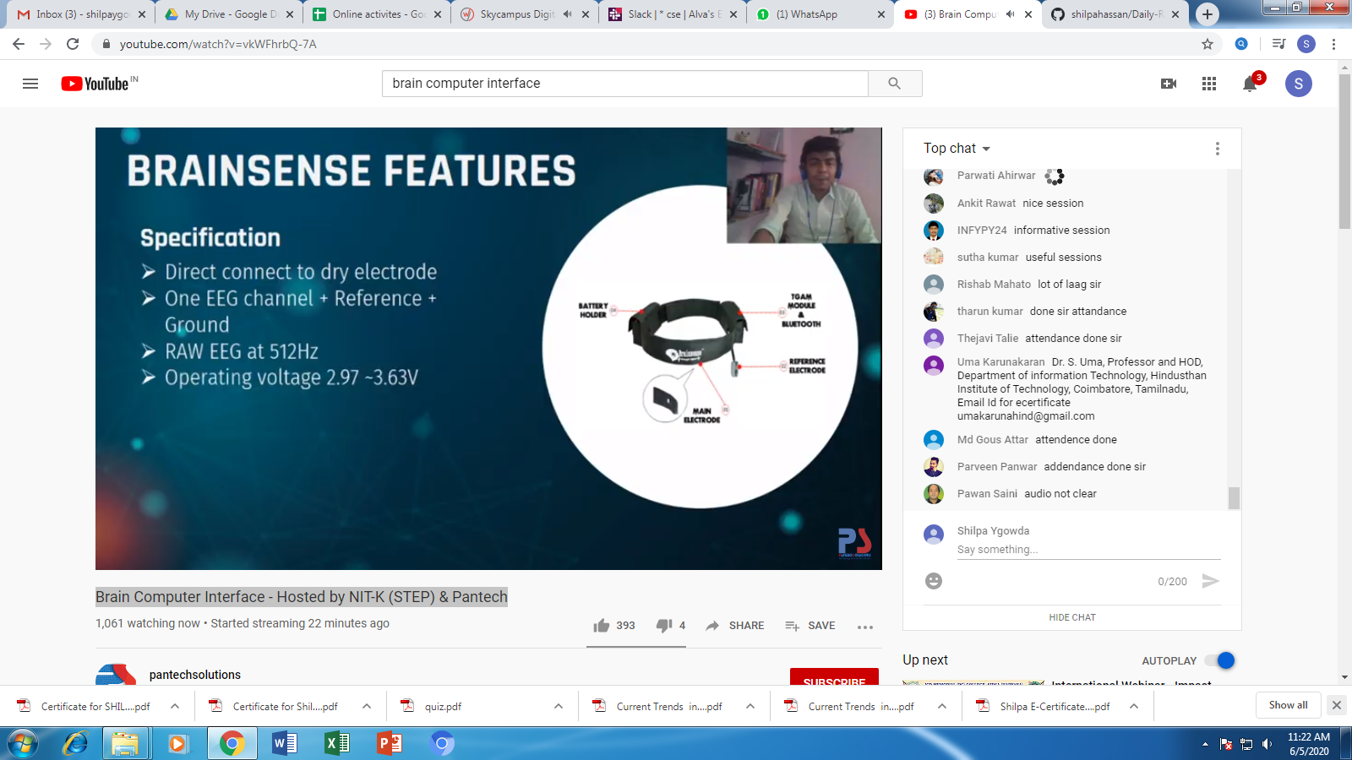

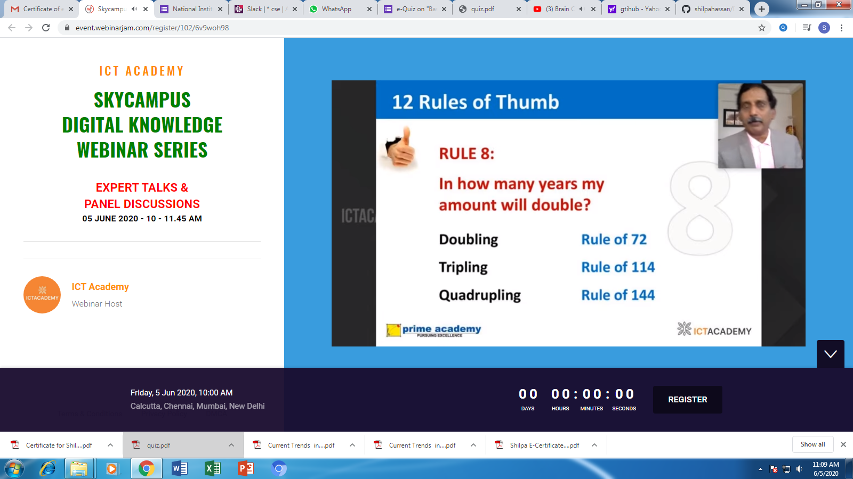



**Students Report:**

